**Adaptive Staircase Experiment**

PSY310: Lab in Psychology

6th September 2024

Saanchi Umesh Bhatt

AU2220151

**Introduction**

A sensory or perceptual threshold can be defined as the minimum intensity of stimulus required to distinguish it from another or for its detection. The adaptive staircase procedure is a standard method in psychophysical and sensory research to estimate the values of sensory thresholds efficiently. These experiments have been widely used in fields like cognitive psychology, neuroscience, other medical sciences, psychophysics, etc.

This technique calculates the perceptual threshold value by adaptively manipulating the stimulus intensity (visual/auditory- the tilt of the grating or the sound of an alarm) per the accuracy of the responses of the participant. This procedure involves starting with a stimulus intensity that the participant can easily distinguish and moving through a series of steps- the stimulus intensity gradually reduces as the participant responds correctly; in case of an incorrect response, the subsequent trial may have an increased or unchanged stimulus intensity, it again goes on to decrease per correct response, making perception more challenging across trials. This iteration goes on for several trials predetermined by the experimenter. This experiment inculcates an adaptive threshold value, the lowest intensity of the stimulus that can be discriminated from another by a participant. It can be derived by calculating the mean of a number of values observed after the final value was attained.

There are several alternatives to the adaptive staircase procedure. The method of limits is one such technique that modifies the stimulus intensity until it reaches its threshold. The stimulus is adjusted in a fixed direction until the observer responds with a negative perception response (or vice versa). The participant's threshold is the average of multiple ascending and descending series. Thus, it is to be noted that the method adopted by an experimenter is determined by the purpose and context of the experiment to be conducted.

In contrast to conventional approaches, adaptive staircases reduce the total number of trials required by clustering trials around the expected threshold. Careful design is necessary to overcome limitations, such as excessively small or large step sizes that may impair the threshold estimate's precision and accuracy. However, it still holds to be a widely accepted and relatively efficient method in the current trends of psychophysics.

**Method**

The participant, age 20, was an undergraduate psychology major student at Ahmedabad University. She was briefed about the purpose and procedure of the study, and her consent was obtained before the start of the experiment. The experimental setup was created using PsychoPy-2024.1.5 software and a 14.5” laptop screen. The experimental design included using a vague shape (grating) with a Gaussian mask tilted towards the left and/or right. The adaptive staircase method is used to estimate the threshold where the participant can detect the presence of the tilt and further determine the correct direction.



This experiment used 100 adaptive staircase trials where the screen first displayed an instruction slide at the beginning of the experiment to revise the instructions and enable the implementation of the developed experiment remotely if needed. A fixation in the form of a polygon (in this case a star) appears for a duration of 0.5 seconds on the screen preceding the flash of the gaussian mask. The size of the Guassian surface was set at a w:0.5; h:0.5, a contrast of 0.5 and a spatial frequency of 8 units (fig 1). The grating (gaussian surface) was flashed on the screen for a duration of 0.5 seconds, and the participants had to detect the tilt of the gaussian surface and press the corresponding keys - “left arrow key” for a left tilt, and “right arrow key” for a right tilt. 

The initial value of the orientation of the tilt was set at 10 units- implying that the tilt would be 10 units to the right or left, decided at random by the program. The further reduction in the degrees and the direction of the tilt is also decided at random by the system. This staircase procedure was a one up three down approach, with the step sizes being: 2. 1.5, 1, 0. The polarity (-ve, +ve sign) of the values noted being indicative of the tilt of the gaussian mask.

The data of the orientation and the response accuracy were recorded every trial, which was downloaded to a csv format kater converted to an excel file in the designated folder in the said laptop. The representative graphs of the same are in fig 2 and 3.

**Results**

A reversal response is categorised by an event of two simultaneous incidents- the response goes from correct to incorrect, and the magnitude of tilt displays an increase. The difference threshold was calculated by omitting the first 30 trials and taking the last five reversal observations from the remaining 70 observations. This was done so as to increase the accuracy of the results obtained- the first 30 trials were the parts where the participant was just getting used to the task and thus may contain greater errors, hence the standardisation. We then calculate the average of the orientation of the last 5 reversals to determine the distinction threshold. The last 5 reversals occurred on the following trials : 63, 72, 76, 82, and 94.

The absolute threshold or the point of subjective equality (PSE) was calculated to be 1.8 degree. This helps us understand that at and beyond this intensity or orientation of the stimulus, the participant was unable to detect or discriminate between the orientation of the tilt of the gaussian mask. Over all, the participant exhibited an accuracy of 81% across an experiment of 100 trials (fig 3).

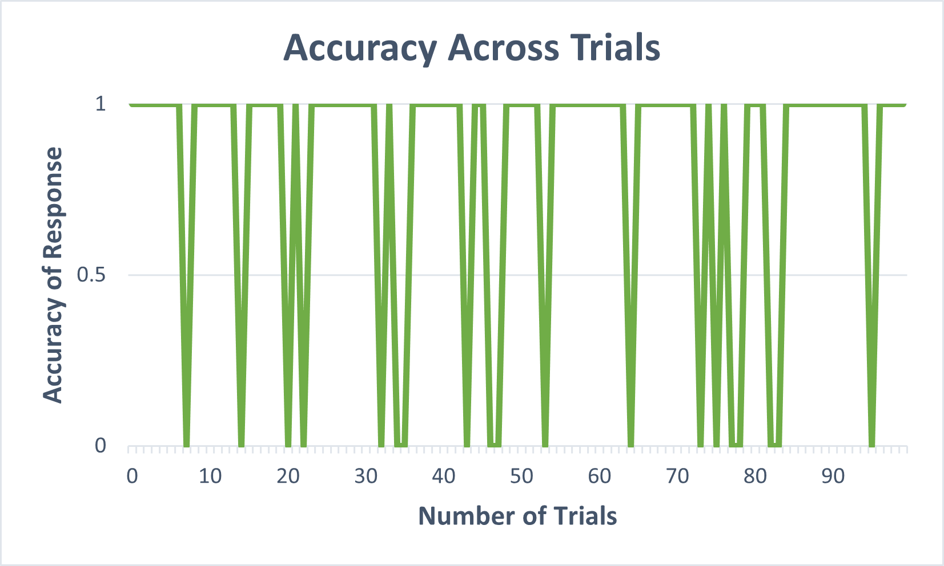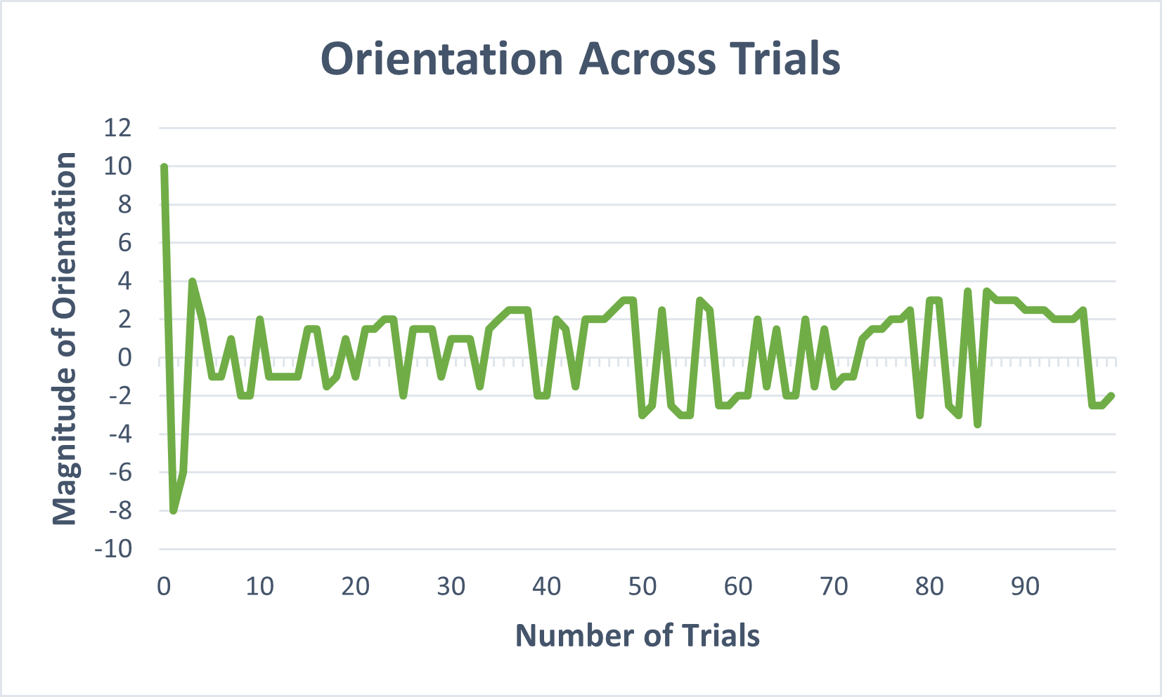

**Discussion**

The data shows us that the participant had a threshold value of 1.8 degrees, with a 81% accuracy in their performance in the experiment. This is a commendable result, indicating a great efficiency of the participant in the discrimination of the tilt of the gaussian mask.

The staircase procedure, however, has its share of drawbacks, including a limited applicability. That is, this can be applied only to controlled lab environments, and the threshold values may vary across not only real life situations, but also in various laboratory settings with different stimuli, distractors, etc.

Another phenomena which may affect the participant’s responses are the assumption of the next tilt based on the previous responses. This may fluctuate the reaction time and the accuracy of the response. There is no uniformity across the participants’ responses regarding the same.

The design of this experiment is very complex and requires a lot of precision to yield accurate results. For example, in scenarios where the step size is too large or too small may either overshoot the threshold, or make the experiment lengthy, reducing the validity of the results produced- the threshold in both cases will be largely incorrect. Finding this accuracy in the properties of the stimuli is vital to the efficiency to the experiment, and often proves challenging.

Despite these drawbacks, the adaptive staircase procedure is widely accepted and used. However, as mentioned earlier, it is wise to choose the method best suited for the research question or hypothesis, and avoid standardization of a particular process across all psycho-physical experiments.

**Citations**

1. Cornsweet, T. N. (1962). The Staircase-Method in Psychophysics. American Journal of Psychology, 75(3), 485. <https://doi.org/10.2307/1419876>
2. Levitt, H. (1971). Transformed Up-Down Methods in Psychoacoustics. The Journal of the Acoustical Society of America, 49(2), 467-477.
3. Karmali, F., Chaudhuri, S. E., Yi, Y., & Merfeld, D. M. (2016). Determining thresholds using adaptive procedures and psychometric fits: evaluating efficiency using theory, simulations, and human experiments. *Experimental brain research*, *234*(3), 773–789. https://doi.org/10.1007/s00221-015-4501-8